System architecture
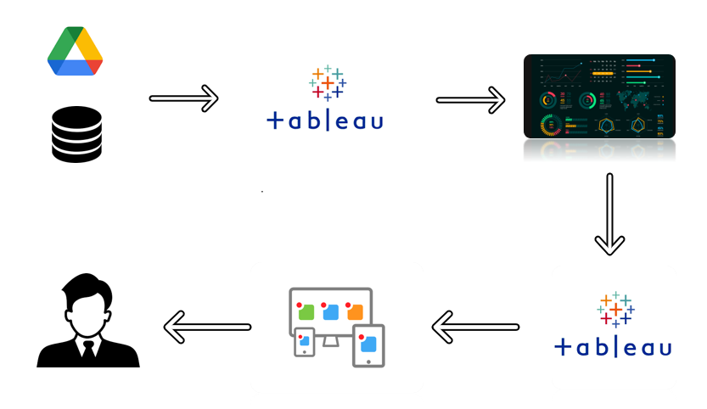
The project follows a cloud-integrated architecture. Data is managed via cloud storage and pulled into Tableau for high-level processing and visualization. These interactive dashboards are then integrated into a Python Flask web environment, allowing the end-user to access complex analytics through a simple web interface.
Technological stack:
Component | Technology Used | Purpose
Frontend | HTML5, CSS3, JavaScript | Building the user interface.
UI Framework | Arsha (Bootstrap 5) | Responsive design and layout.
Backend | Python (Flask) | Server-side routing and logic.
Data Viz | Tableau Public | Creating interactive market charts.
Version Control | GitHub | Hosting and project management.
Ideation | Mural | Empathy mapping and journey mapping.

Proposed Solution
Our proposed solution is a centralized web dashboard that simplifies complex Apple market data. By embedding Tableau 'Stories' into a Flask-based web application, we provide a seamless experience for users to explore 16 years of iPhone data without needing technical expertise.

